**How to Use**

**User Guide**

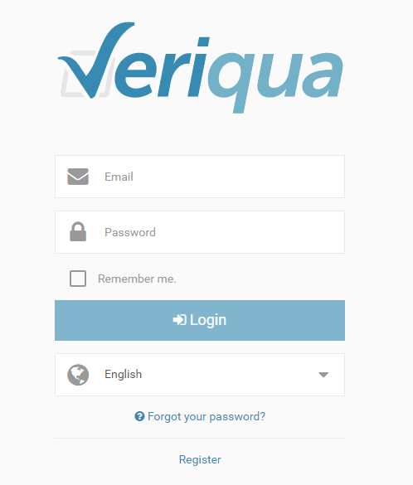

This guide provides step-by-step instructions and helpful tips for conducting a self-managed internal audit for your organization.

Throughout the guide, look for important information labelled ***!Please Note*** as well as helpful tips labelled ***Tip***.

**Table of Contents**

Registering …………………….…………………………………………………………………………...3

Supported Web Browsers…………………………………………………………………………...8

User Permissions …………………………………………………………………………………………8

Initial Login………………………………………………………………………………………………….9

Forgot your Password………………………………………………………………………………..11

Managing My Organization Information …………………………………….….……….…13

Managing your Profile Information……………………………………………………………20

Adding a New Audit……………………………………………………………………………………21

Making Changes to an Audit………………………………………………………………………26

Deleting an Audit……………………………………………………………………………………….27

Rating an Audit ………………………………………………………………………………………….28

Viewing Results ……………………………………………………..………………………………….33

Viewing the Dashboard …………………………………………………………………………….41

Using Action Plans …………………………………………………………………………………….42

Logging Out …………….……………………………………………………………………………..…45

## Registering

Register at any time from the login page.

Click on [Register]:



Registration takes 5 steps:

1. Provide your email address and click [Next]:

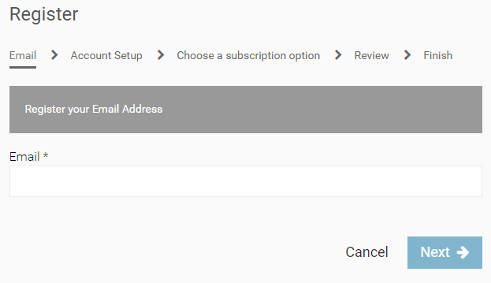

1. Complete your profile information, including setting your password:

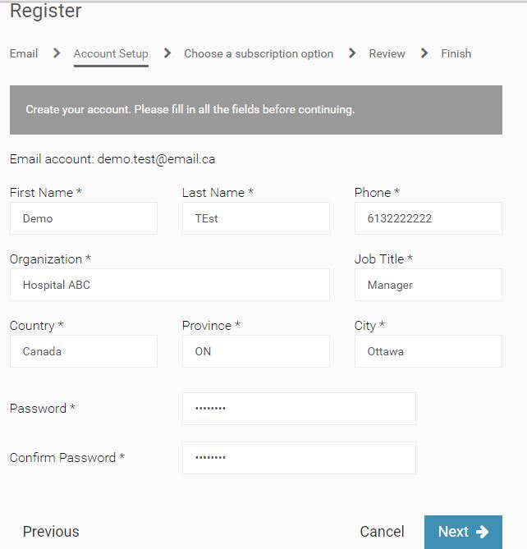

1. Select your subscription type from the available options:

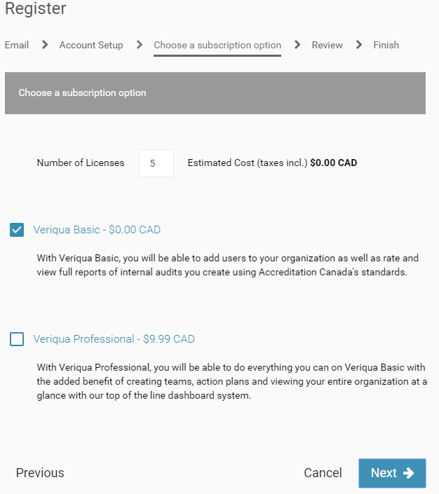

1. Review your subscription and payment information (if applicable) and click [Submit]:

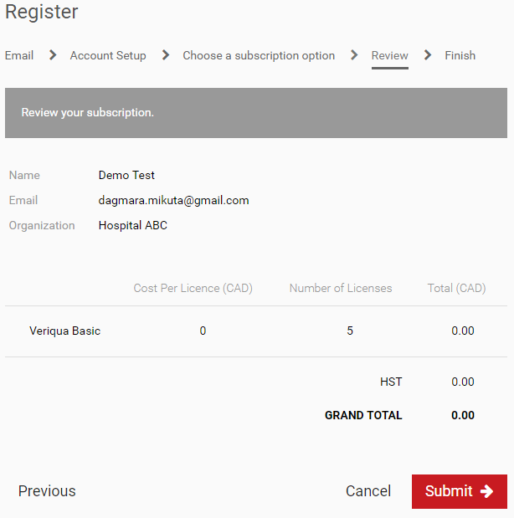

Completing this step will trigger an email invitation that will be sent to the email address provided, prompting the recipient to set up their account.

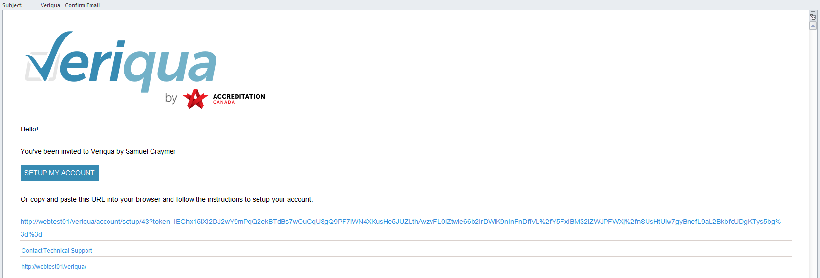

1. Complete your subscription by clicking on [Finish]:

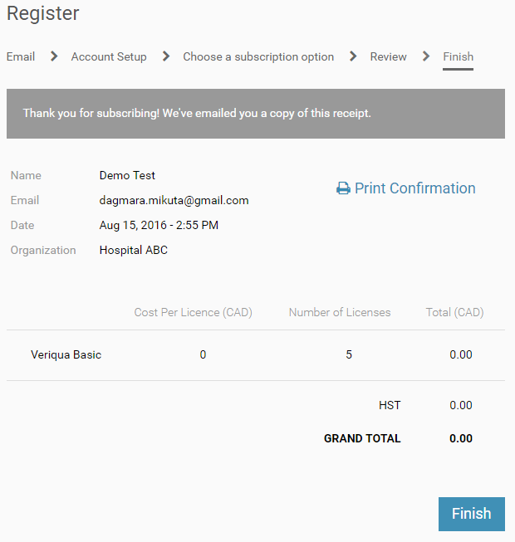

## Supported Web Browsers

***! Please note:*** Support for use on Internet Explorer 11 or higher, latest versions of Mozilla Firefox and Google Chrome.

## User Permissions

User accounts and access permissions are set for each licensed user. Here’s a brief description of each type:

* Users with permission to **Manage Subscriptions & Users** are responsible for their organization’s subscription and user licenses.
* This user role will have the ability to:

▪ Manage subscription information

▪ Manage user accounts including setting permissions

▪ Create an audit

▪ Invite Users to an audit

▪ Manage the list of audits

▪ Rate audits

▪ Review results and export data for all audits

* Users with permission to **Manage Audits** cansetup audits for their organization.
* This user role will have the ability to:

▪ Create an audit

▪ Invite Users to an audit

▪ Manage the list of audits

▪ Rate audits

▪ Review results and export data for all audits

* Users with permission to **Rate Audits** can complete audits that have been assigned to them.
* This user role will have the ability to:

▪ Rate audits

▪ Review results and export data

***Tip:*** A user license is not required to access audit results. If you have access to the audit, you can simply share the URL link with anyone who may be interested in viewing the results. See page 40 of this guide to find out more.

## Initial Login

New licensed users will receive an email request to confirm their email address.

Follow the link found in the email:



Create a password to complete your profile.

The profile section is also where you can set your language preference:

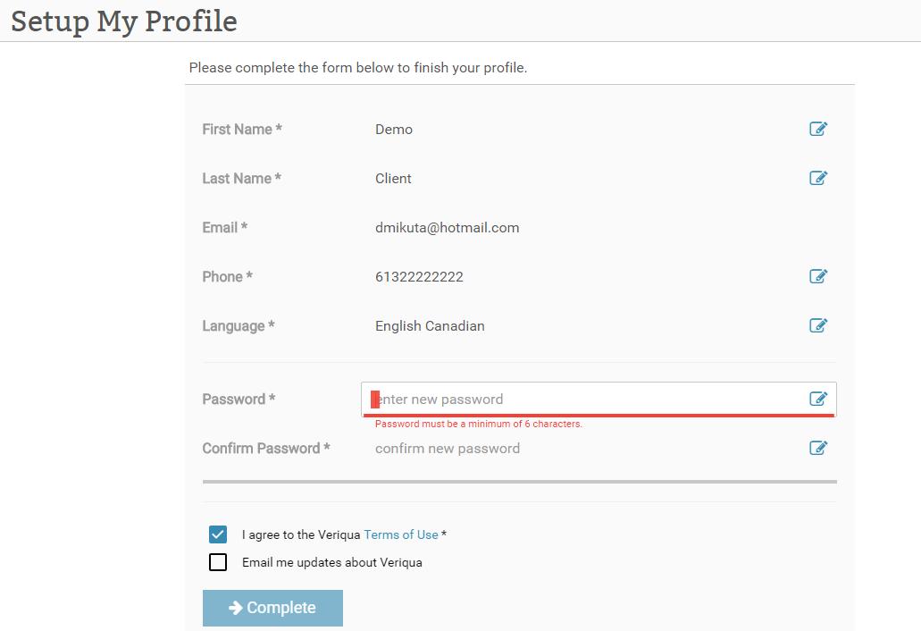

Once this is done, you’ll be able to login using your email address and password:



When you login, My Audits will be the first page you’ll see:

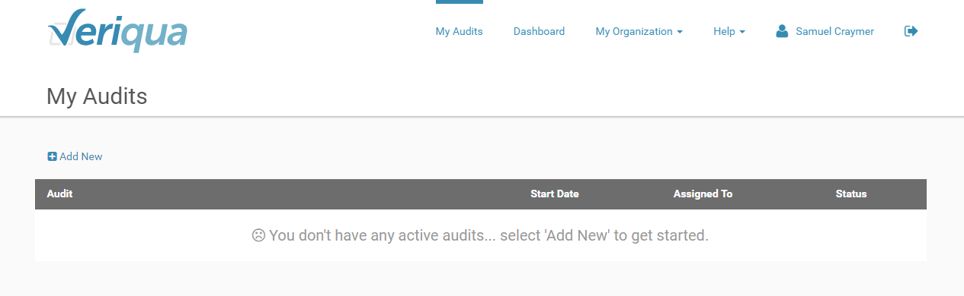

## Forgot your Password

If you forget your password, you can reset at any time it by clicking on [Forgot your password?] from the login page:



Enter your email address and click on [Send]:

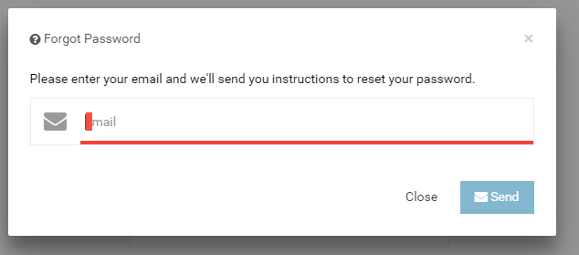

You’ll receive a password reset email.

Click on [Reset my Password] from the email: 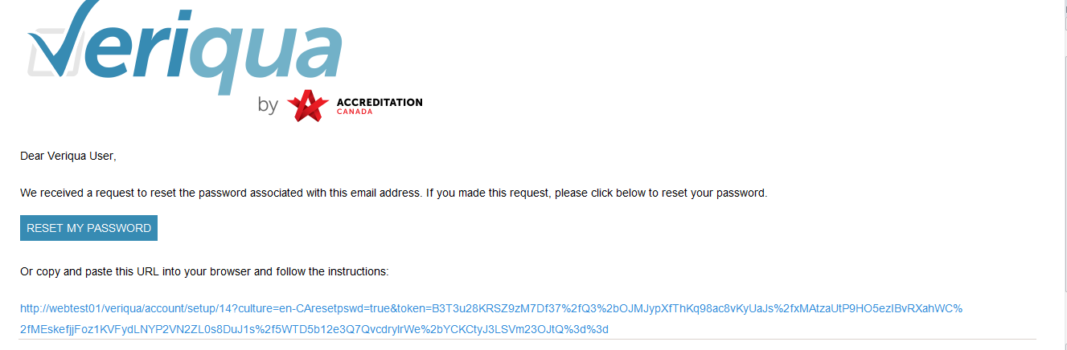

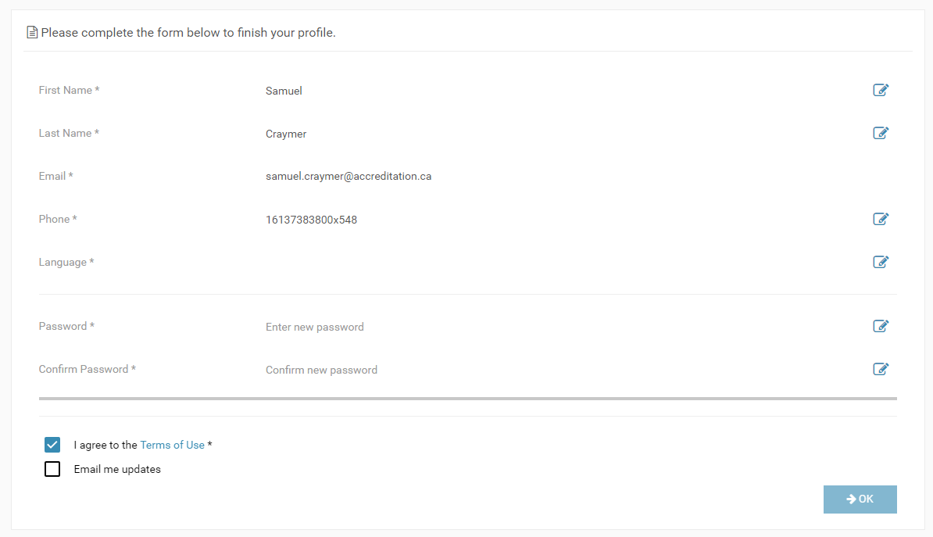

## Managing My Organization Information

If you are an Administrator, you’ll see **My Organization** as an option from the menu:

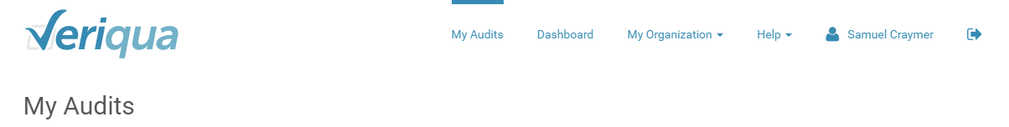

From this tab, you’ll be able to manage your organization’s subscription and billing as well as manage user accounts included in the subscription. You’ll also be able to add and edit custom Locations and Departments used in audits for the organization.

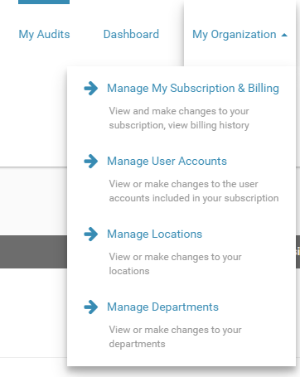

### Manage My Subscriptions & Billing:

This menu allows you to view and make changes to your subscription as well as access your billing information:

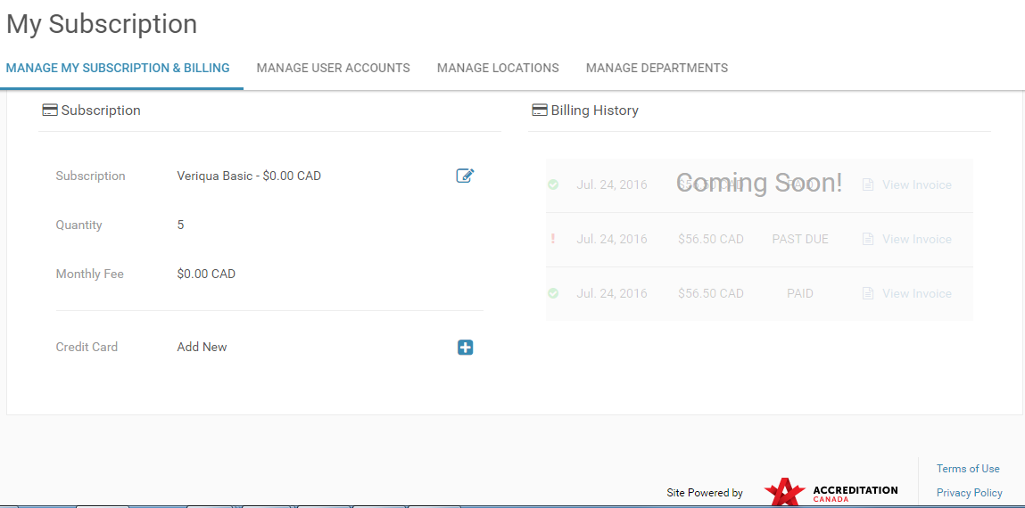

**Change Subscription Details**

Click on the edit icon to change your subscription or edit the number of licenses available to your organization and click on [Update]:

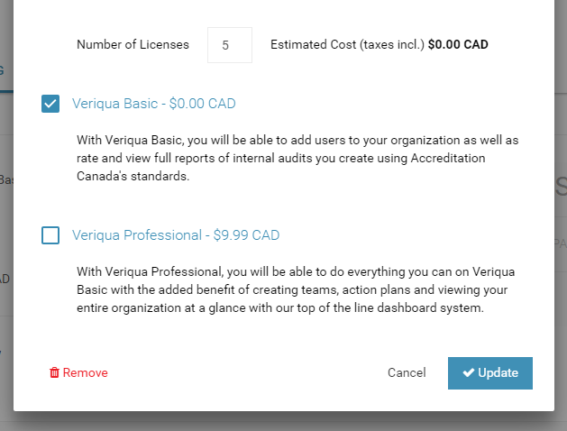

Clicking will cancel the subscription at the end of the billing period.

The edit window will close and a red alert will be displayed at the top of the page indicating when your subscription will end with a date, like this:

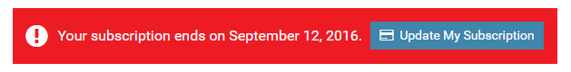

**Update Credit Card Information**

To add or update your credit card information, click on the  symbol and enter the card number, expiry date and CVV and click [Update] to save:

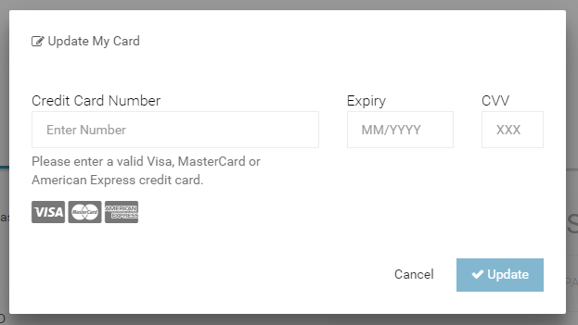

### Manage User Accounts:

The Manage User Accounts menu allows you to invite users to join as well as manage individual user permissions.

***Tip:*** Users can also be invited from the My Audits page.

**Invite User**

Based on the number of licenses you have as part of your subscription, users can be invited to join at any time.

Click on [Invite User] to assign a user license:

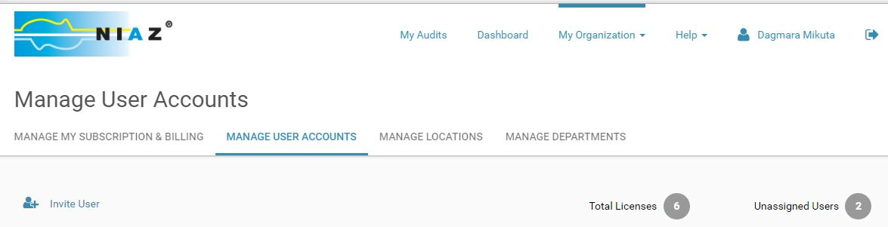

Enter the user’s email address and specify what they will be able to do by setting their permissions. By default, all users will be permitted to rate audits.

Click [Send] to invite the user through email to create their profile and set their password to be able to login:

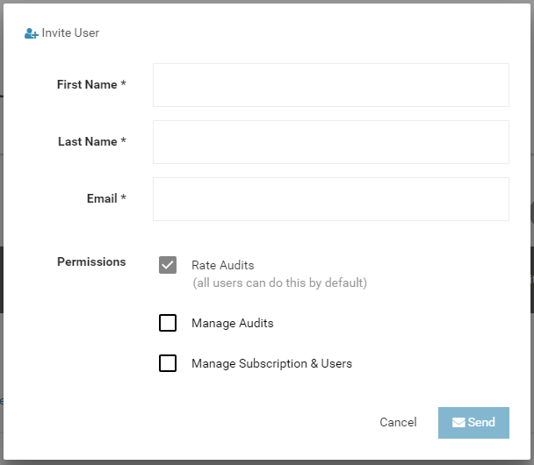

**Edit User Account**

Use the edit icon to make changes to the user’s information or delete the user account so you can re-assign the license if needed.

Click [OK] to save: 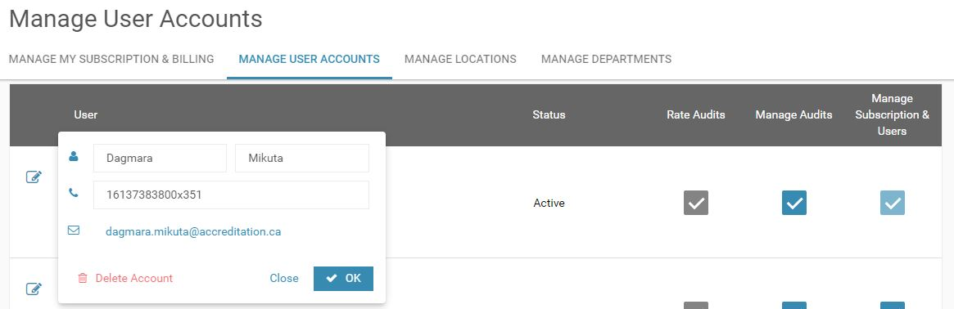

***! Please note:*** When deleting a user account, the user will become inactive. Any audits currently being rated by this user will not change. If the audit hadn't been rated yet by the inactive user, it can be assigned to someone else. If they already started the audit, consider making a copy of it to assign to a new user.

To change the user’s permissions, simply check (or uncheck) the applicable box:

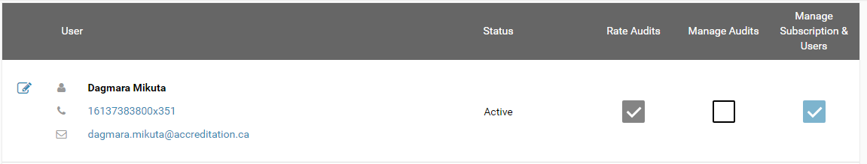

### Manage Locations

You have the option to add and edit custom locations and tag them to specific audits for your organization. Using locations will allow you to compare audit results by location in the Dashboard.

Click on [Add New] to create a location:

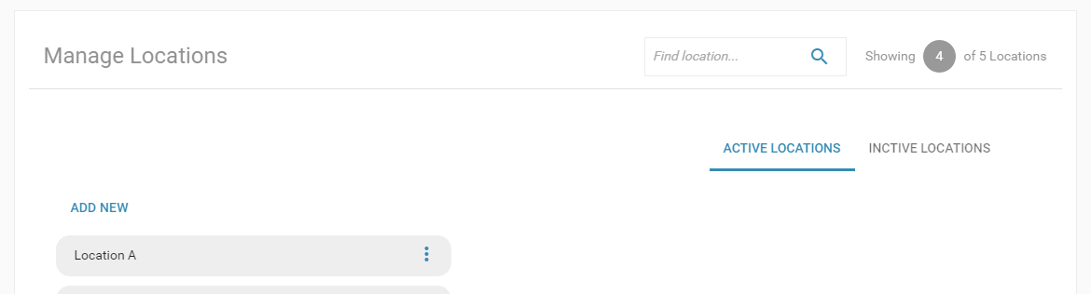

From your list of locations, click on  to bring up the menu, allowing you to edit location name or make it inactive, as needed.

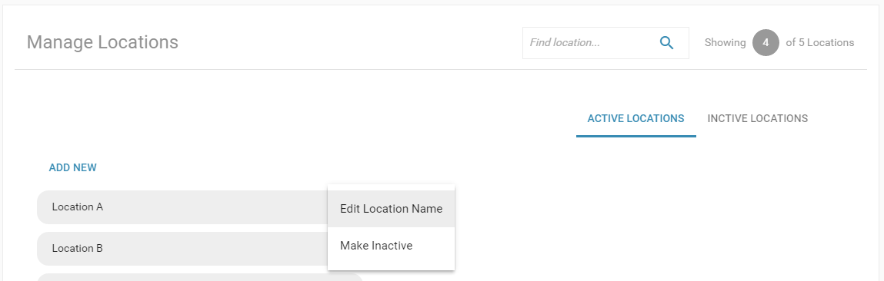 Use the search option or filter the list to show only locations that are active/ inactive.

***! Please note:*** Results will not be available for inactive locations.

### Manage Departments

You have the option to add and edit custom departments and tag them to specific audits for your organization. Using departments will allow you to compare audit results by department in the Dashboard.

Click on [Add New] to create a department:

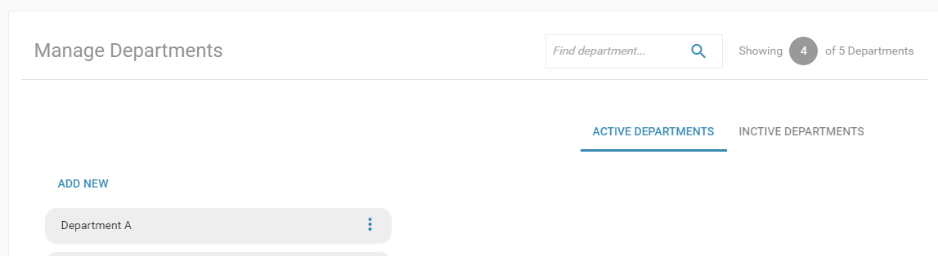

From your list of departments, click on  to bring up the menu, allowing you to edit department name or make it inactive, as needed.

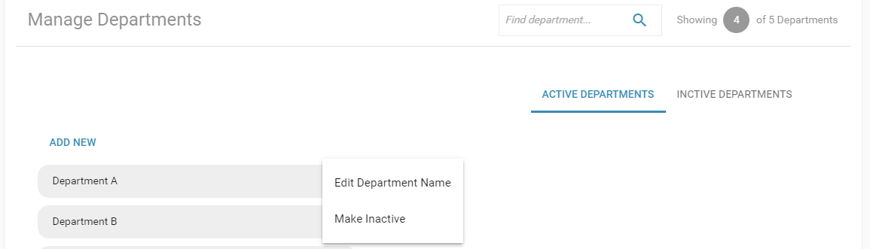

Use the search option or filter the list to show only departments that are active/ inactive.

***! Please note:*** Results will not be available for inactive departments.

Managing your Profile Information

Update your profile information at any time by clicking on your name in the top right corner of the page. This will allow you to change your password, update your email address or set your language preference:

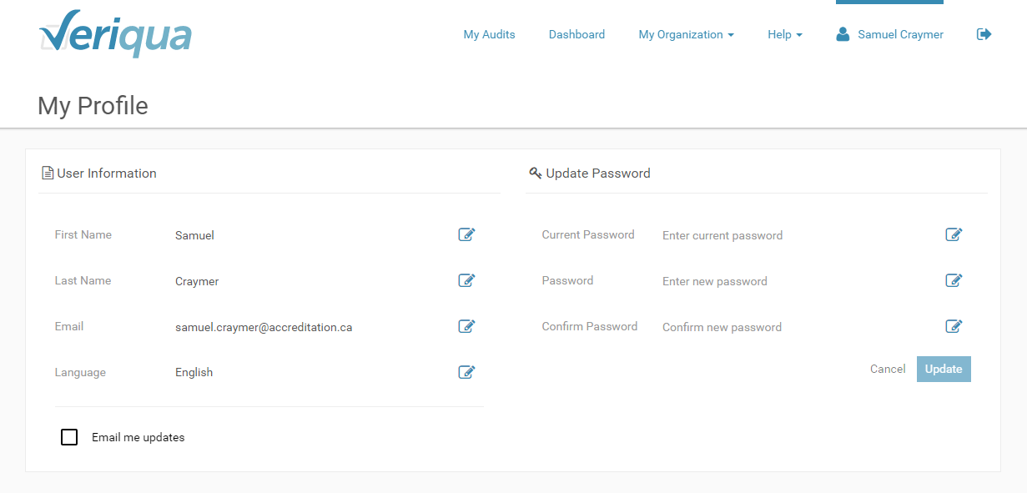 ***Tip:*** Setting your language preference in your profile will determine in what language you’ll see content:

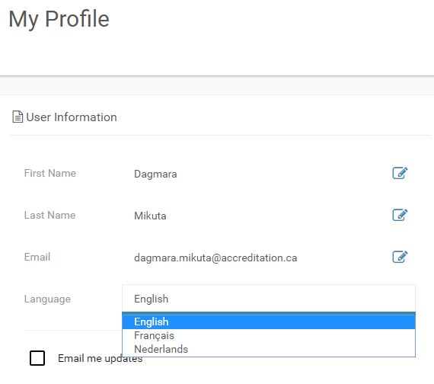

## Adding a New Audit

To create a new audit:

1. Navigate to the My Audit*s* page and click on [Add New]:

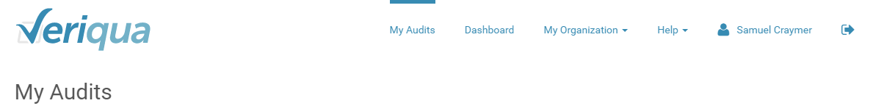

1. Select which standard(s) to include in the audit.

Use the keyword search to filter the list of standards to show only those that discuss a particular topic (e.g., rehab, pharmacy, hand hygiene, etc.):

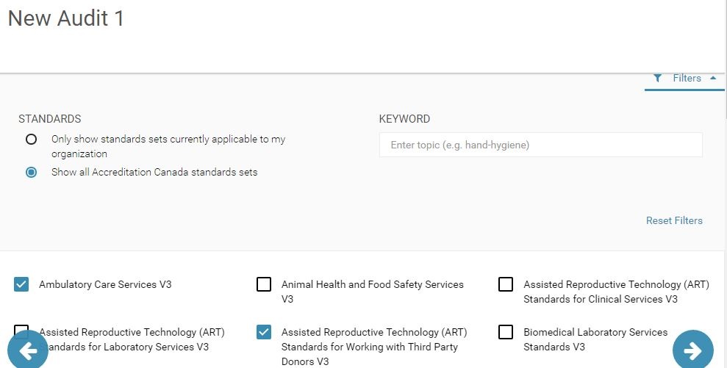

Expand/ collapse the filter options depending on what you want to see

1. From the standard(s) you’ve selected, specify which specific criteria to include.

You can include all criteria for the selected standard(s) or select which specific criteria to include by checking off which ones to use in the audit.

Limit the criteria shown on screen by using filters (you can filter by *standard section*, *criteria type* or by *quality dimension, theme, level or keyword*):

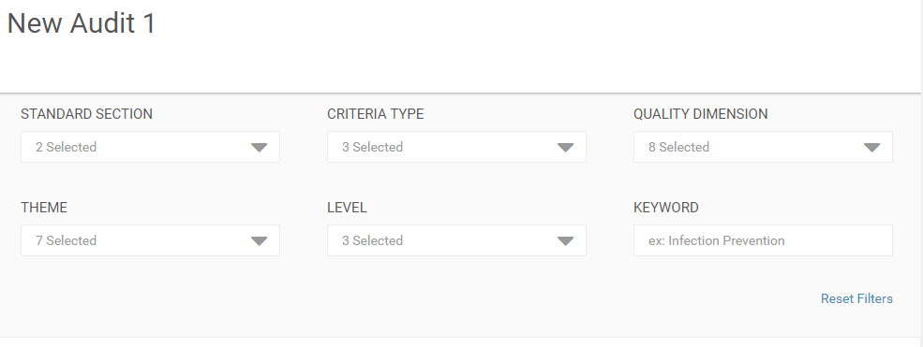

Look at the number of criteria listed as Showing—this number will tell you how many criteria have been filtered out based on your selection:

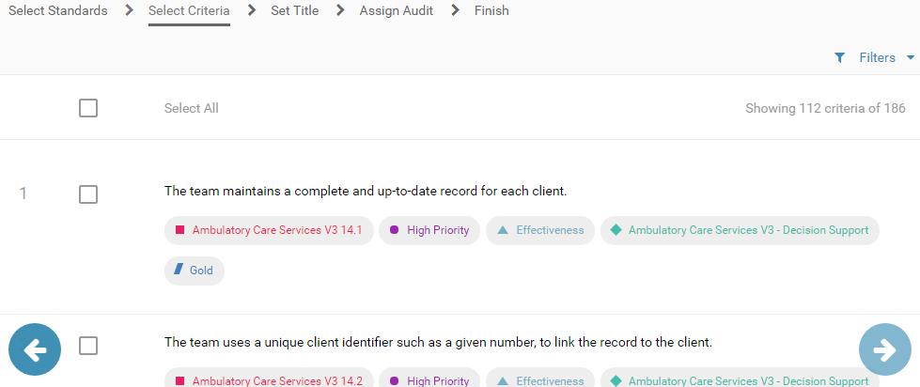

1. Enter a title for the audit and include an optional description to provide more information about the audit:

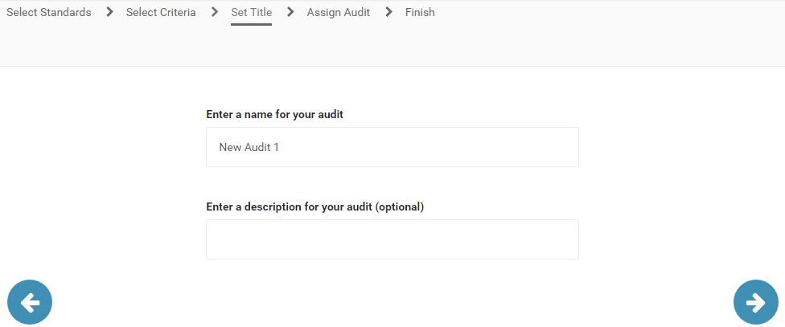

1. Specify who will be rating this audit by selecting the name of an existing user from the drop down list.

The people in this list will be the users that have been added as part of your organization’s subscription.

**! Please Note:** Each audit can be evaluated once, so you can only assign one Evaluator per audit.

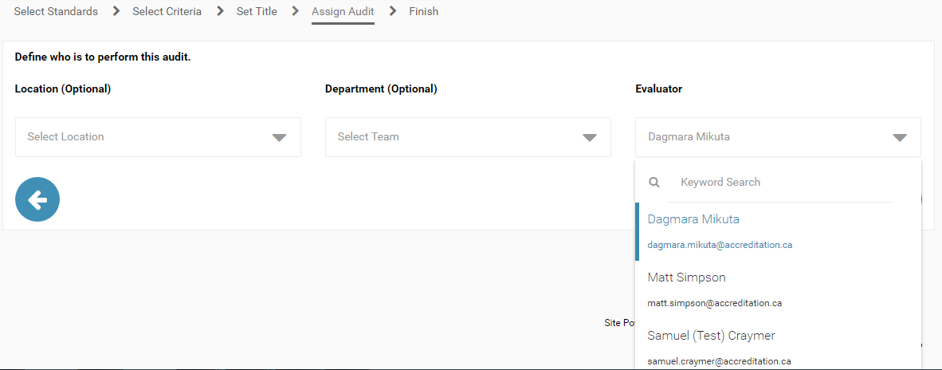

The Evaluator will receive an email once he or she has been assigned to the audit.

**Copying an Existing Audit**

Use an existing audit to quickly create one or more copies which you can assign to different Evaluators.

To use the same standard(s) and criteria of an existing audit, click on [Copy] below the audit title on the My Audits page: 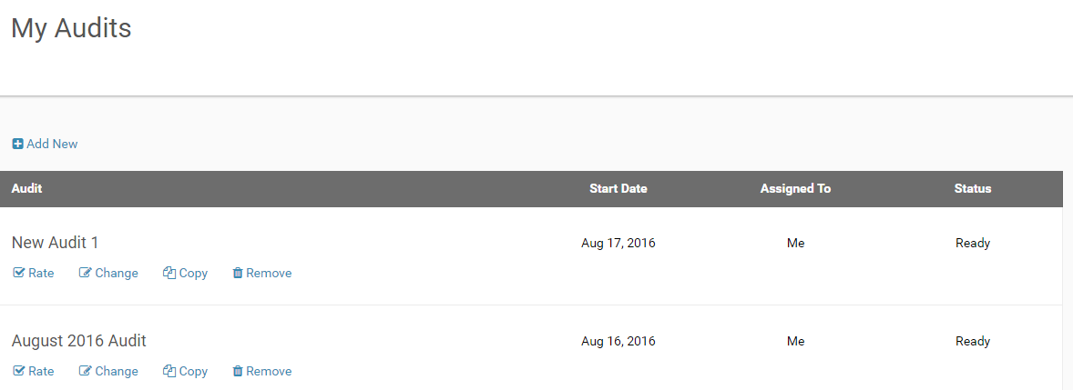

Doing this will let you skip steps 2 and 3 of creating a new audit and you’ll jump ahead to setting the title:

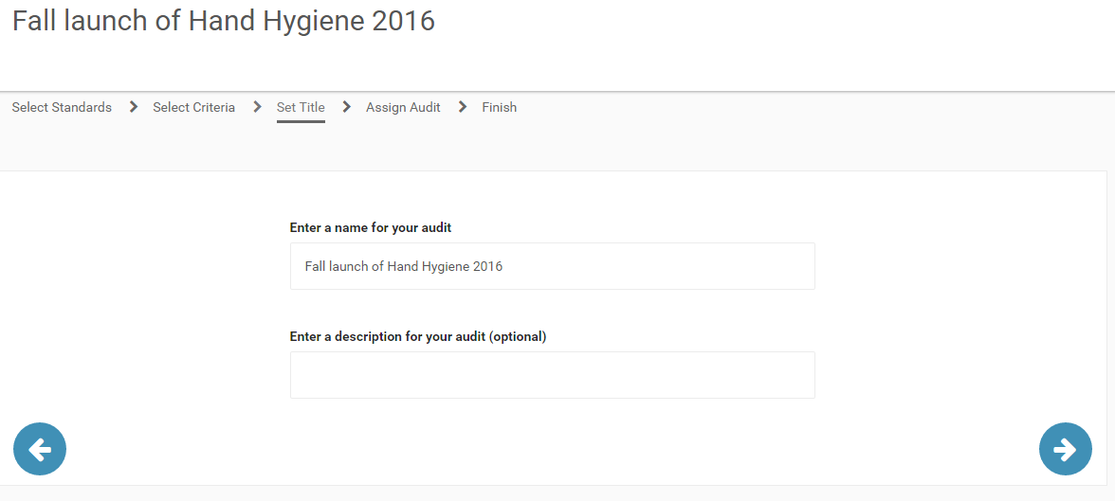

And assigning the Evaluator: 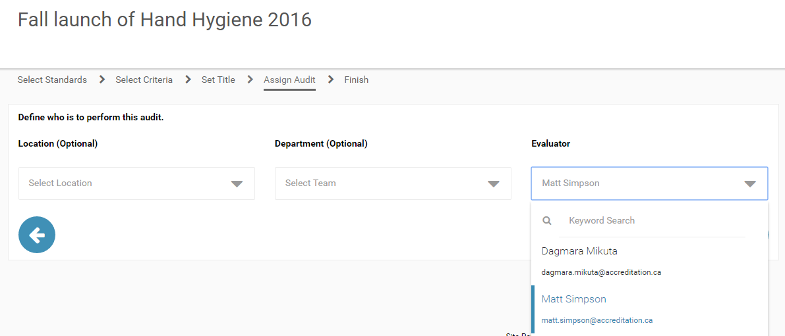The audit will be ready to be rated:

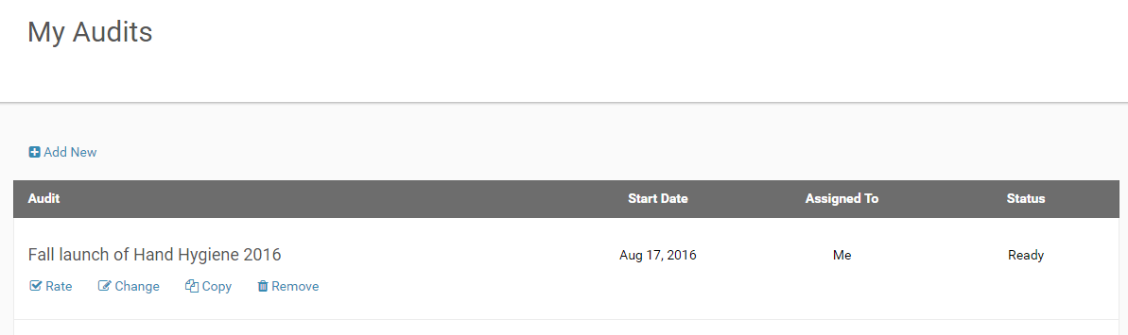

## Making Changes to an Audit

Changes can be made to an audit before the Evaluator begins rating.

To modify an audit:

1. Go to My Audits.
2. Click on [Change] below the selected audit title:

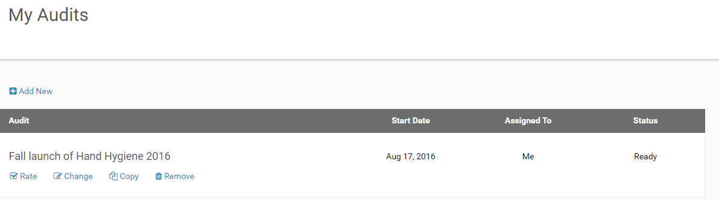

1. This will take you back to through the steps of creating the audit, allowing you to modify it as you need and save the changes.

**! Please note:** An audit can only be modified before ratings have been started. The [Change] button will only be available for audits status listed as “Ready”:

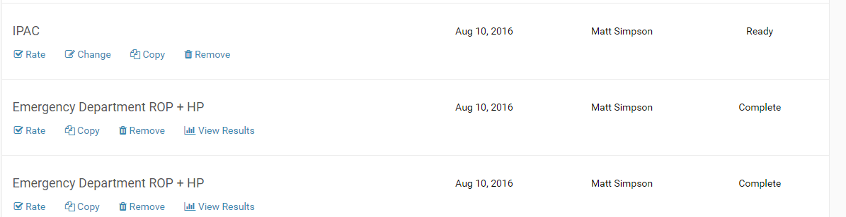

## Deleting an Audit

Any existing audits can be deleted.

To delete an audit:

1. Go to My Audits.
2. Click on [Remove] next to the selected audit:

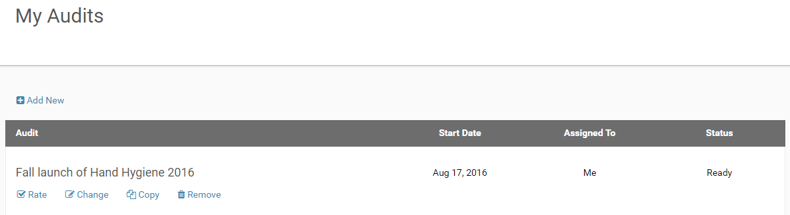

1. From the dialogue window, click [Remove] to permanently delete the selected audit:

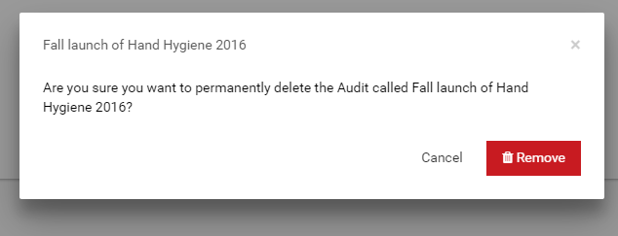

## Rating an Audit

Evaluators can begin rating criteria once an audit has been assigned to them.

To rate an audit:

1. Go to My Audits.
2. From the list of audits, click on [Rate] below the selected audit:

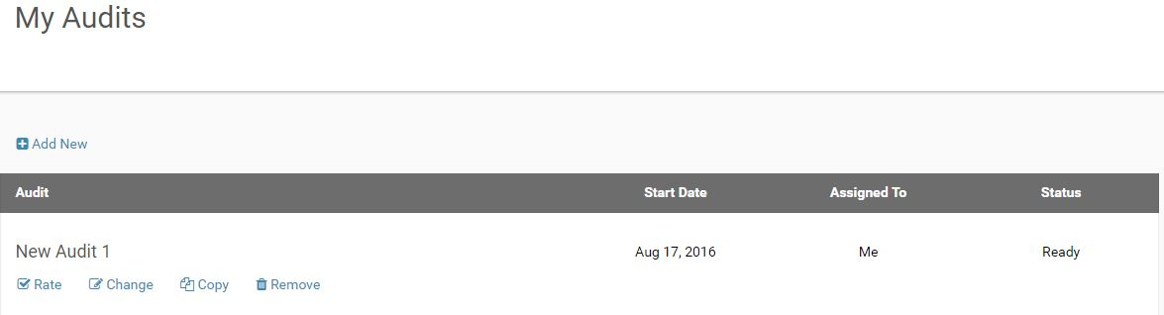

Audit criteria will be rated as In Place, In Progress, or Not in Place: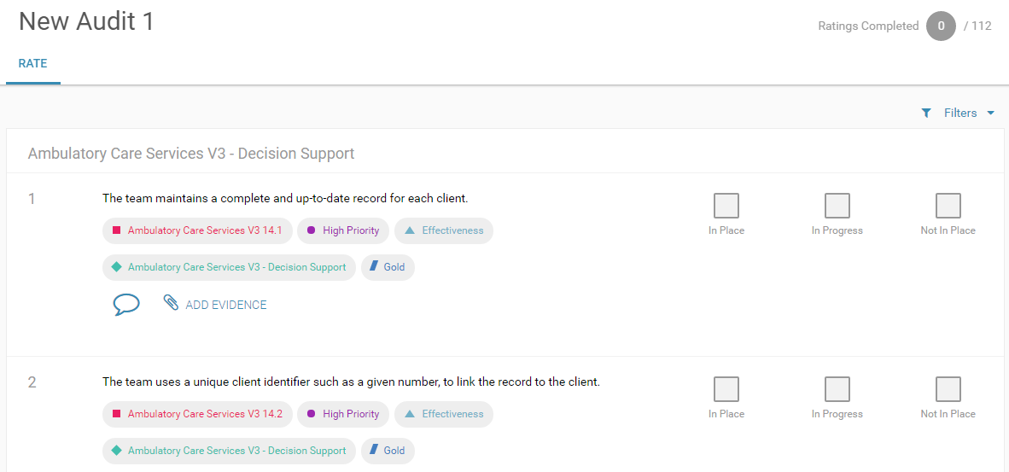

Expand the filters to narrow down the list of criteria shown.

For example, filter the list to hide criteria that has already been rated: 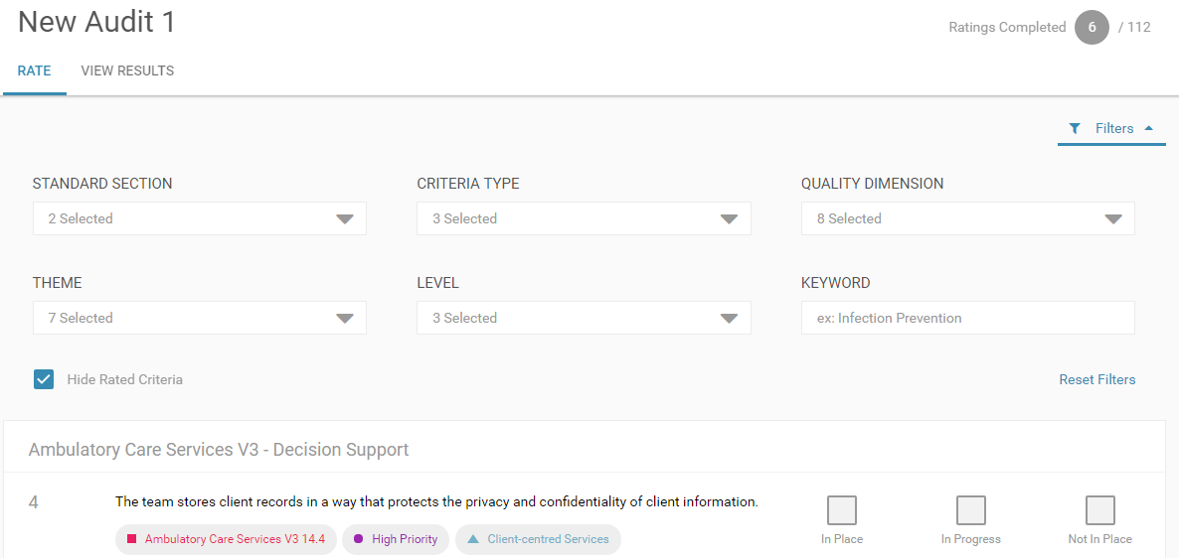

Click on [Reset Filters] to remove the filters that have been applied.

The “Show/ Hide Guidelines” toggle allows you to view additional information about how a criterion can be evaluated:

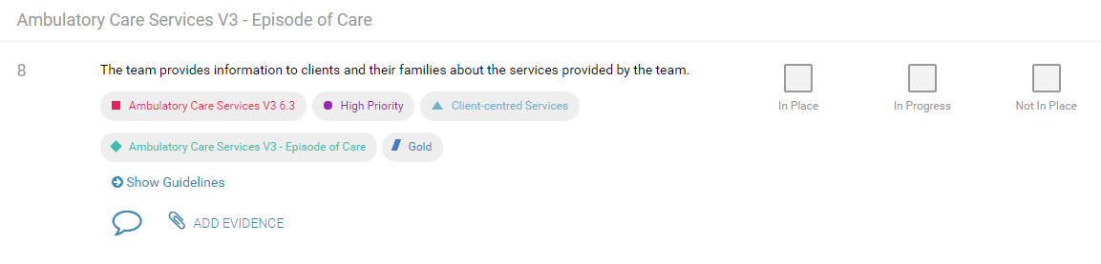

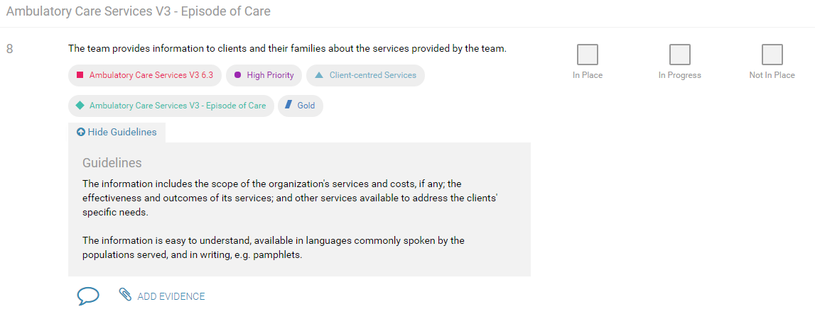

**Adding Comments**

Comments can be entered and saved using the comment icon found below each criterion.

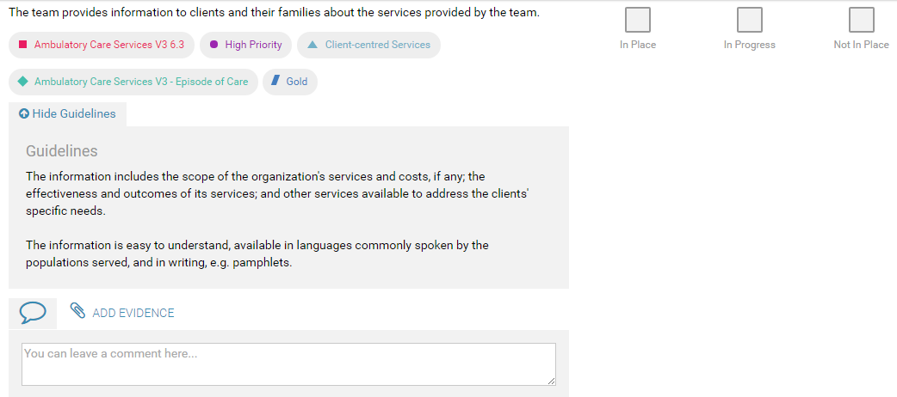

**! Please note:** Comments entered will be saved automatically and will appear in the results for the audit.

**Adding Evidence**

Evidence such as documents or images can be added to each criterion. Select [Add Evidence] and click on [Add New] to upload one of the following files types: Documents(PDF, Microsoft Word, Excel, PowerPoint) and Images: 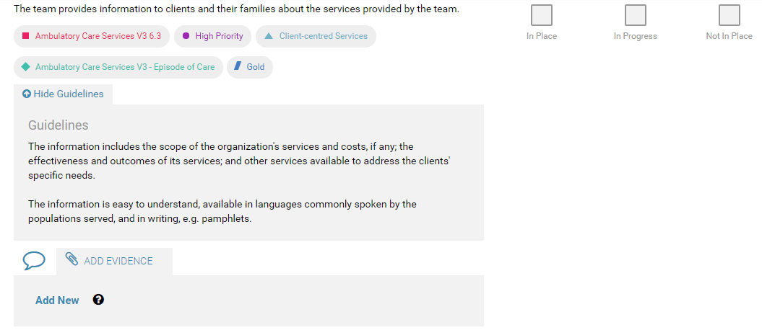

**! Please note:** Uploaded files will appear in the results for the audit.

## Viewing Results

Results can be viewed for an audit that is either in progress or has been completed.

Click on [View Results] from within the audit: 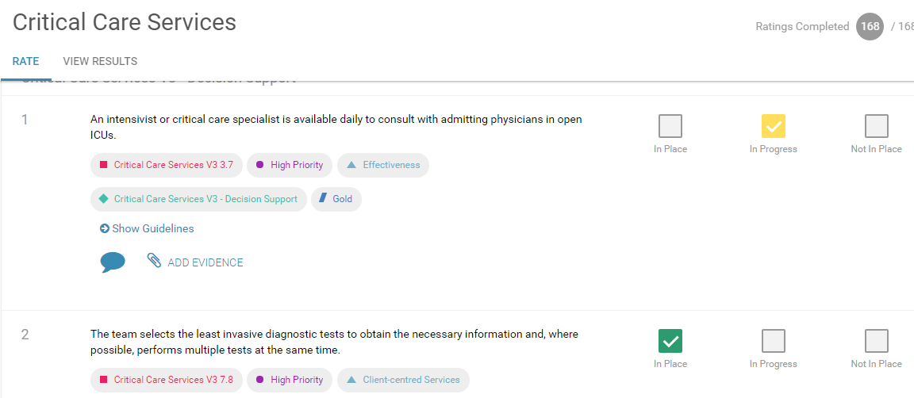

Or below the selected audit from the My Audits page: 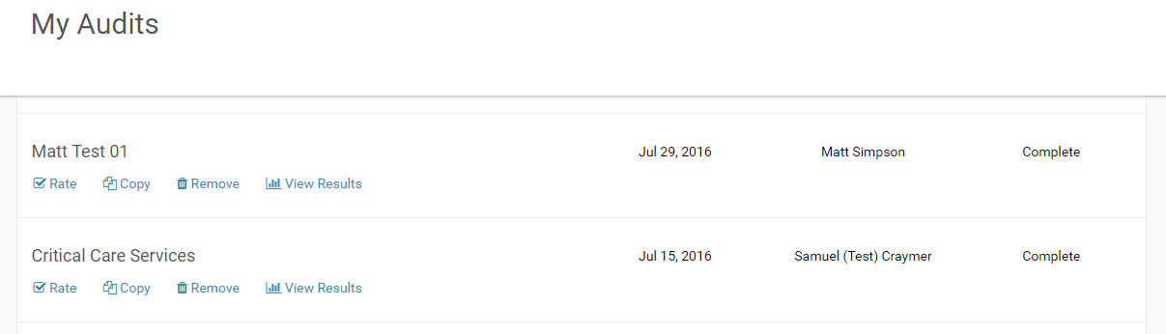

**View Results- Summary**

The first view of the results will be a summary by selected grouping: 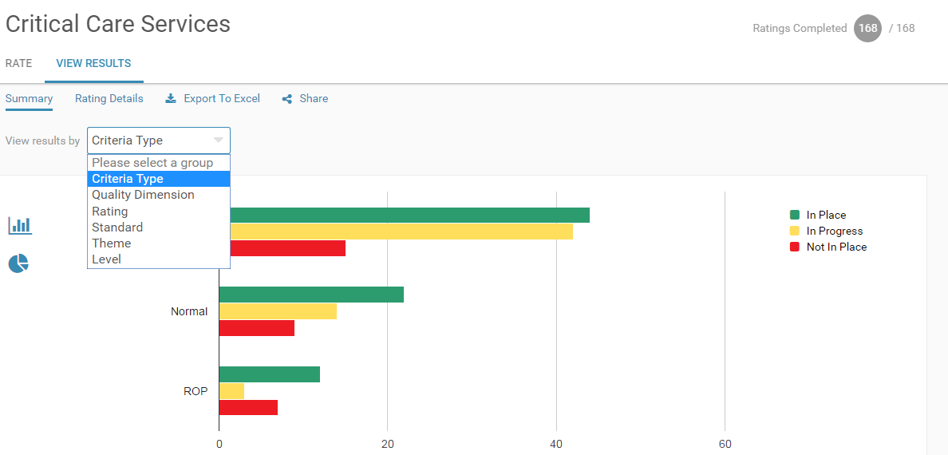Alternatively, you can select to view the audit data in a pie chart:

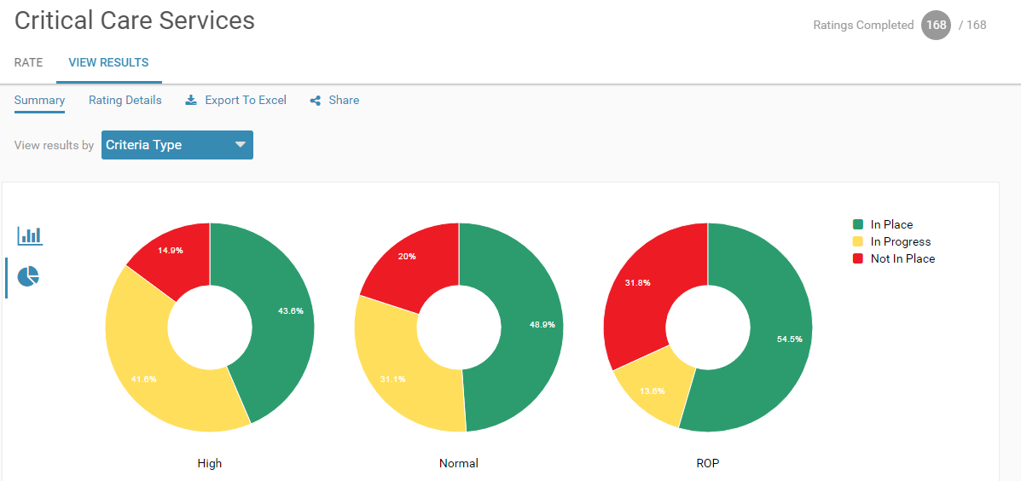

***Tip:*** Hover your mouse over a segment to view more details in the graph:

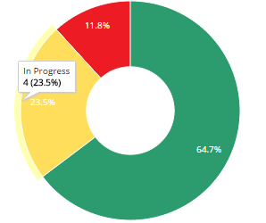

**View Results- Rating Details**

Click on [Rating Details] to get a more detailed view of audit results.

Filter results to view them by two dimensions (select the grouping and applicable type): 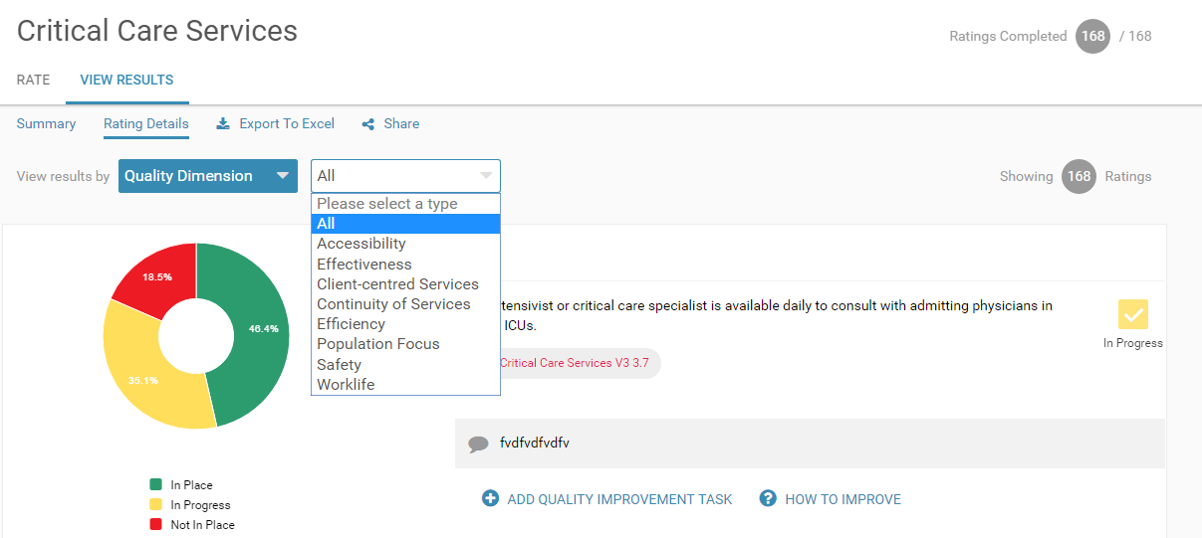

Comments and evidence files will be available below the applicable criterion.

**View Results- Add Quality Improvement Task**

A quality performance improvement task can be added for any criterion and will be linked to an Action Plan created for the audit. The task can also be assigned to be completed by another user.

Click on **[Add Quality Improvement Task]** and fill in the task details:

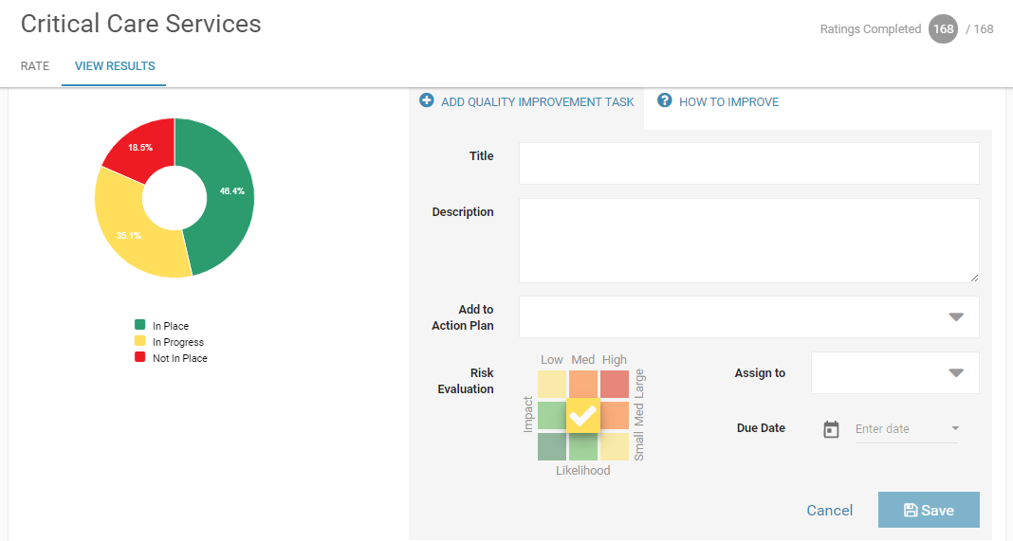

**! Please note:** A quality improvement task requires an action plan. If no action plans exist at the time of creating a quality improvement task, a new action plan can be created by clicking on the plus symbol from the action plan drop down:

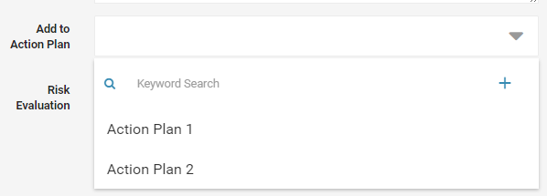

Assign the quality improvement task by selecting the user from the Assign to drop-down. Users assigned to a quality improvement task will receive an email notification to prompt them to login.

**! Please note:** A new user can also be added by clicking on the plus symbol from the Assign to drop down:

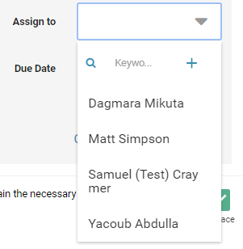

Complete the risk evaluation matrix by selecting the field which intersects with the impact on the organization if the criteria is not in place and the likelihood of it happening if the criteria isn't in place:

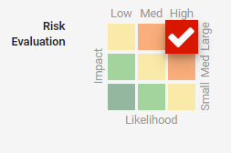

**View Results- How to Improve**

Additional resources for the quality improvement task are available by clicking on [How to Improve].

These will open up links to videos and print resources that can access when working on the task:

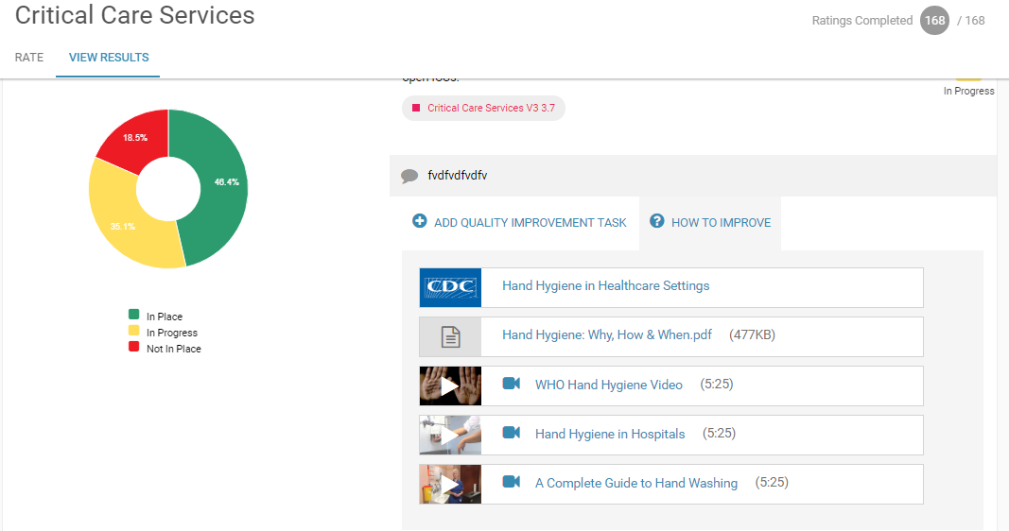

**View Results- Export to Excel**

Audit results can be exported to Excel.

Click on [Export to Excel] from the View Results page: 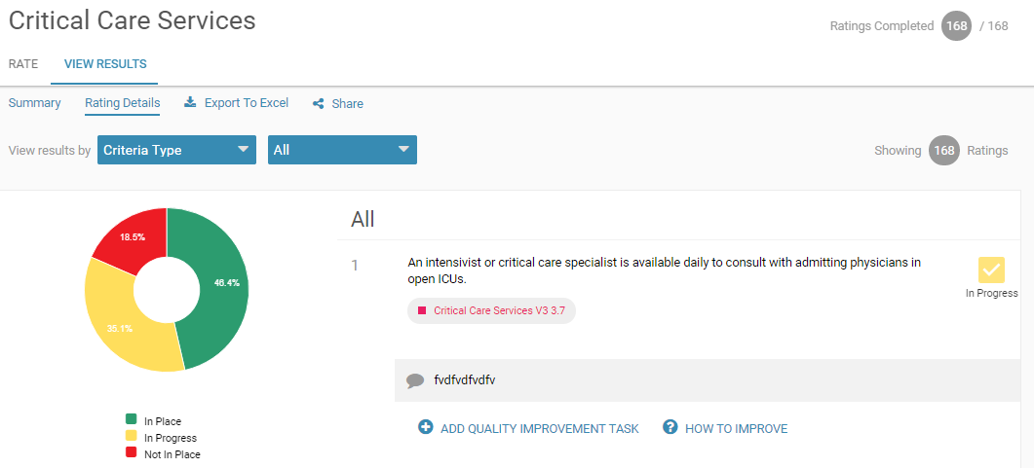

This will import the raw data for the audit into an Excel file, allowing you to complete your own analysis of the results:

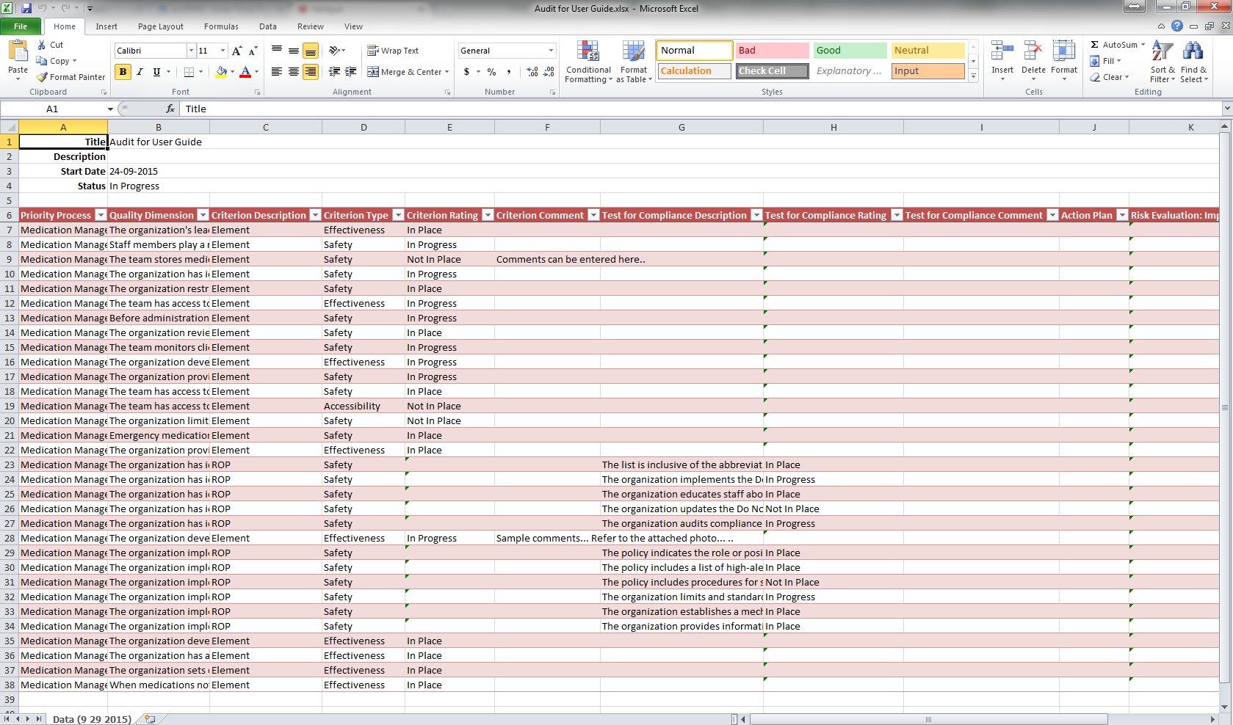

**View Results- Share**

Use the [Share] button to bring up the link to the audit results.

Copy and paste the link and share it with anyone you wish to give them access to the audit results:

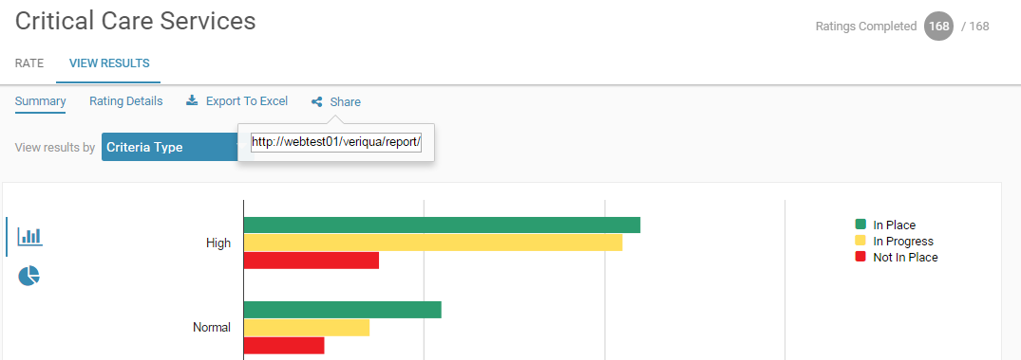

**Tip:** A user does not need to login to view the results from the link you’ve shared with them, so the link can be shared with anyone who wishes to see the results regardless of whether they have a licence.

## Viewing the Dashboard

The dashboard displays the organization’s overall performance during a selected timeframe and by applicable location and/ or department: 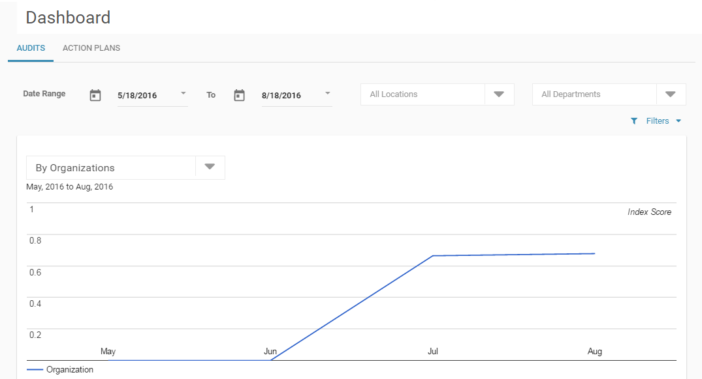

The dropdown allows you to cut the data in different ways. For example, you can select “By Locations” and all locations will appear in the list below and in the line graph.

The graph has an index score (from 0 to 1) that is based on the audit ratings that allows benchmarking; [2 * (In Place Count) + (In Progress Count)] / [(In Place Count) + (In Progress Count) + (Not in Place Count)].

The colour coding in the table below is also based on this index score, the more green the close to 1 it is, them more yellow the closer to .5 it is, the more red the close it is to 0.

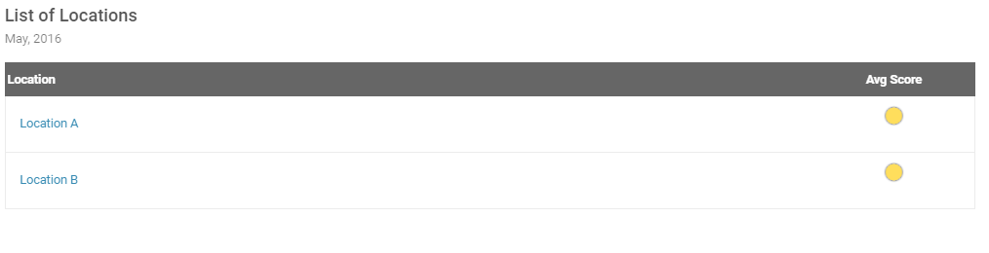

## Using Action Plans

Action plans display the groupings of quality improvement tasks for the organization. Quality improvement tasks will be listed as Completed, In Progress or Not Started.

If your organization has many action plans, filter the list of action plans by using the search bar:

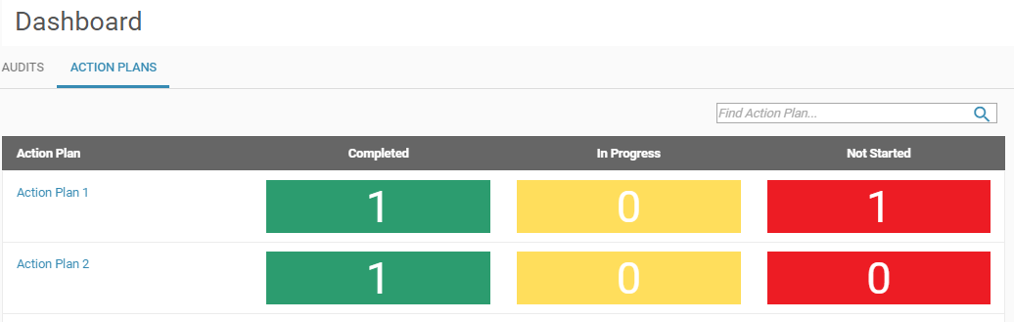

Click on the action plan to view the details:

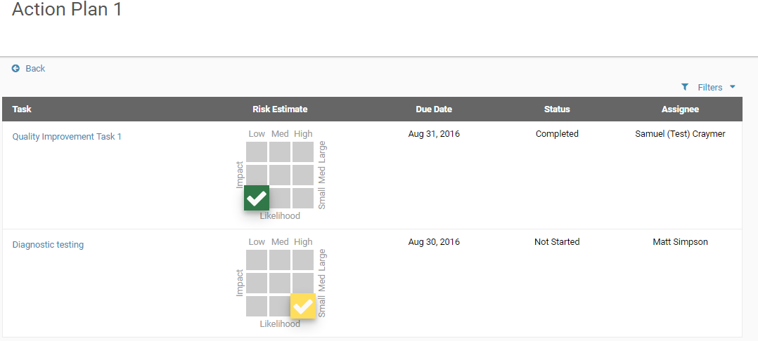

Expand the filters to narrow down the list of criteria shown: 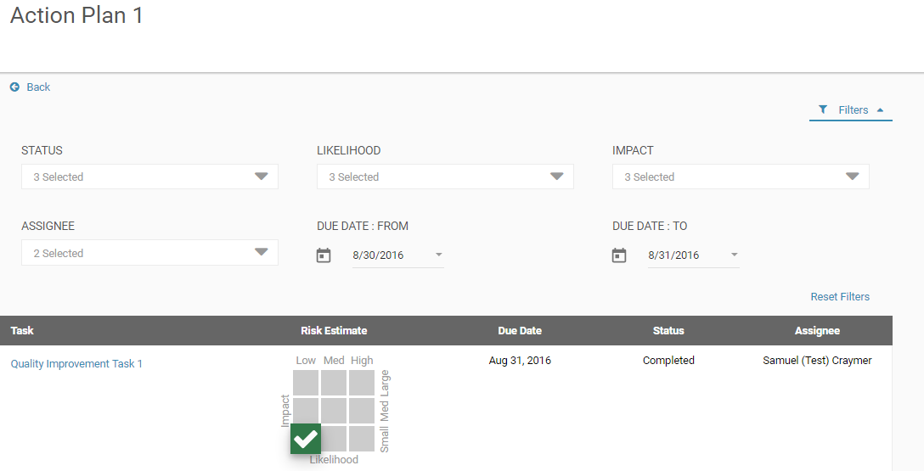

To view the details or to complete the quality improvement task, click on the task:

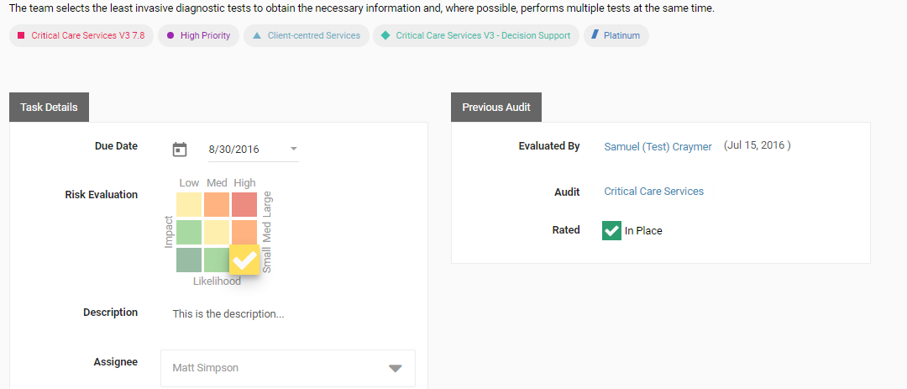

Scroll down to view the Evidence of Action taken.

This is where the user assigned to complete the task can prvide their comments and attach supporting evidence: 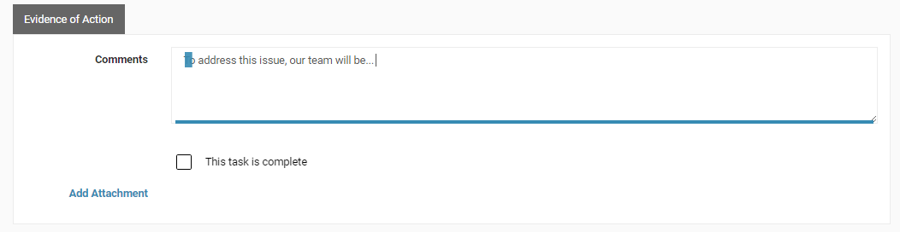

Below will be links to videos and other resources that have been compiled to help you improve:

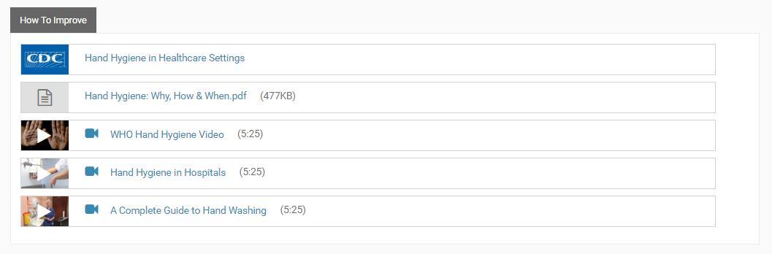

The task will remain In Progress until it has been marked as completed. To complete a task, check off [This task is complete]: 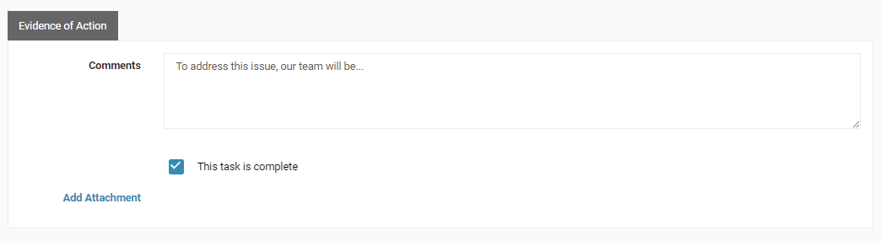

## Logging out

It is always recommend logging out when you want to end your session.

Use the arrow on the top right to log out of the website:

